MIRACLE OF WACTHWORD

What is your opinion on one time password generator??? Like that I would like to create a password storage on which is similar to password generator but it is more different.

So,my main product is a password storage one which is called miracle of watchword means showing of our miracle passwords watchword is password in (dutch).

Main purpose of using it??

Usually we generate or store different types of password , because of different website accept only different types of passwprd pattern types like it should have 8 digits only ,it should have one special character (@#$%&\*),it should have differet no(12345).for these types of password we will save different passwords. But after few days we will forgot password because we have saved in different types.

Main reason to use??

We will save our passwords in laptop like auto fill, save etc… if in case we forget our laptop or phone but we have to immediately login from another device means we get a problem…… we wont have phone also to generate otp or mail etc.

In that time we can store password in password generater we can store every password in that to identify easily it will show website name,username,password you have saved . We can store different types of files format in that through camera , if want we can store sd cards ,

Structure of watchword

It is type of smart watch display ,we want to see clearly or big in size it will extend like small flip display we can see clearly and can increase the letters font,size also , it is touch pad having camera on the back side. it is runned by keeping of the charge to it,it will have battery saver too .it is of hand size,easy to carry,pocket friendly ,less in weight

Dimensions

If that display is like smart watch display means it will be 3x3 inch, if extended like flip display means it will be 3l,6b(3x6inch).single clear camera with 1080Tpixel camera.

Security

it cannt be accessed by any one it can be access by main users fingerprint or iris detection only. Ones user have iris stored means every when he use it he can use fingerprint, if want he can give permission to 2 members who can access rather than him.we also like to keep some strong firewalls if it approves

Images

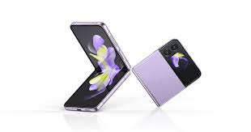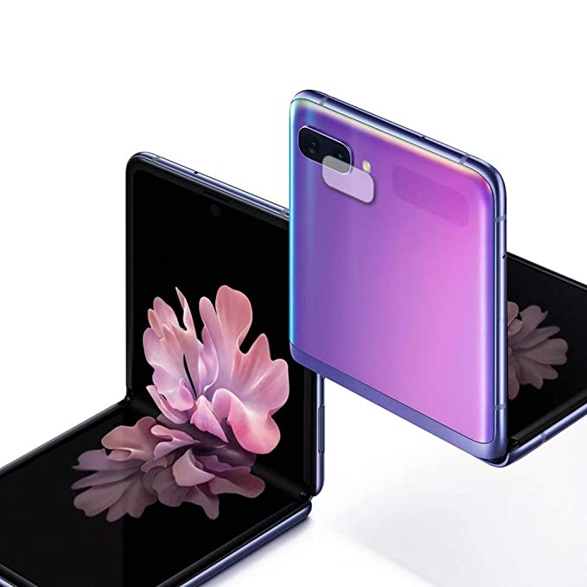

It is model by size will be 3x6inch,3x3inch

It will extend in both ways

We want to do further work on the security and design format